

**NATIONAL ECONOMIC CONSULTATIVE FORUM**

**MONTHLY ECONOMIC BULLETIN**

**JUNE 2024**

# Executive Summary

This bulletin focuses on economic developments for the month ending 29 June 2024 that include Zimbabwe Gross Domestic Product (GDP) growth updates, merchandise trade developments, exchange rate developments, inflation developments, monetary developments and stock market developments as well as world economic developments and international commodity prices.

The global economic growth is projected to hold steady at 2.6% in 2024 despite flaring geopolitical tensions before edging up to 2.7% in 2025 and 2026 alongside modest expansions of trade and investments (World Bank Group, June 2024 Global Economic Prospects). Global inflation estimated to fall to 3.5% in 2024, before easing further to 2.9% and 2.8% in 2025 and 2026, respectively.

Regarding commodity prices, crude oil and natural gas prices gained by 4.8% and 0.54% respectively while prices of aluminum, copper, nickel, gold, cotton, soyabeans, corn and wheat fell on a m-o-m basis.

According to the World Bank Group, June 2024 Global Economic Prospects, economic growth in Zimbabwe is projected to reach 3.3% in 2024 before picking up to 3.6% in 2025 and slightly slowing down to 3.5% in 2026. There projections are higher than the estimates of IMF in its April 2024 WEO report.

Regarding foreign exchange market, the ZiG depreciated against all major currencies (USD, GBP, EUR and ZAR) during the period under review. On the other hand, the USD gained against GBP and the EUR by 0.73% and 1.21% respectively, albeit depreciating by 1.62% against the ZAR.

During the month under review, the economy continued to record a deflation, m-o-m inflation stood at -0.2% up from -0.6 recorded in May 2024. The main contributors to inflation being housing, water, electricity, gas and other fuels, and food and non-alcoholic beverages.

Meanwhile, during the reporting period data on merchandise, trade broad money supply (M3) and interest rates for June 2024 had not been published by Zimbabwe National Statistics Agency (ZimStat) and the Reserve Bank of Zimbabwe (RBZ), thus this analysis remain unchanged from the April 2024 Economic bulletin.

Concerning the stock market, during June 2024 both the Zimbabwe Stock Exchange (ZSE) and Victoria Falls Stock Exchange (VFEX) recorded a bullish trend. On ZSE, all-share index gained by 1.6%, top 10 index gained by 34.53%, value traded grew by 3380.24% and market capitalization grew by 31.24%. Similarly, on VFEX, all-share index gained by 5.57% and market capitalization grew by 8.38% while value traded lost by 85.64%.

Table of Contents

Executive Summary i

1.0 World Economic Developments 1

1.1 World Output 1

1.2 Global Inflation Developments 1

2.0 International Commodity Prices 2

3.0 Zimbabwe GDP Growth Update 3

4.0 Merchandise Trade Developments 4

5.0 Exchange Rate Developments 4

5.1 Zimbabwean Dollar Exchange Rate Developments 4

5.2 Cross Rate Developments 4

6.0 Inflation Developments 5

7.0 Monetary Developments 6

7.1 Money Supply and Interest Rates 6

8.0 Stock Market Developments 6

8.1 Zimbabwe Stock Exchange 6

8.2 Victoria Falls Stock Exchange 6

9.0 Recommendations 7

10.0 References 8

**List of Tables**

Table 1: Global Economic Growth Developments 1

Table 2: Commodity Price Movements – Month Ending 28 June 2024 3

Table 3: ZiG Exchange Rate Movements – Month Ending 28 June 2024 4

Table 4: USD Exchange Rate Movements – Month Ended 28 June 2024 4

Table 5: Monthly Inflation for June 2024 5

Table 6: Zimbabwe Stock Exchange Movements 6

Table 7: Victoria Falls Stock Exchange Movements 7

**List of Figures**

Figure 1: Global Inflation Prospects 2

Figure 2: Zimbabwe Economic Growth Prospects 3

Figure 3: Month-on-Month Inflation Outturn 5

# 1.0 World Economic Developments

## **1.1 World Output**

1.1.1 The Global economic growth is projected to hold steady at 2.6% in 2024 despite flaring geopolitical tensions before edging up to 2.7% in 2025 and 2026 alongside modest expansions of trade and investment (World Bank Group, June 2024 Global Economic Prospects). Despite some improvements, outlook remain subdued due to disruption in trade network and climate change (see Table 1).

Table 1: Global Economic Growth Developments

|  |  |  |  |
| --- | --- | --- | --- |
|  | 2024 | 2025 | 2026 |
| Global | **2.6** | **2.7** | **2.7** |
| Advanced Economies | **1.5** | **1.7** | **1.8** |
| United States | 2.5 | 1.8 | 1.8 |
| Euro Area | 0.7 | 1.4 | 1.3 |
| Emerging Markets and Developing Economies | **4** | **4** | **3.9** |
| China | 4.8 | 4.1 | 4 |
| India | 6.6 | 6.7 | 6.8 |
| Sub-Saharan Africa | **3.5** | **3.9** | **4** |
| Nigeria | 3.3 | 3.5 | 3.7 |
| South Africa | 1.2 | 1.3 | 1.5 |

*Source: World Bank Group, June 2024 Global economic Prospects*

1.1.2 According to the World Bank Group June 2024 Global Economic Prospects Report, both advanced economies and emerging markets and developing economies and Sub-Saharan Africa (SSA) are projected to grow at a slower pace from 2024 to 2026 than in the pre-pandemic period. A subdued global growth reflects the lagged effects of monetary tightening and resumed fiscal consolidation, while an upgrade to global growth forecasts in 2024 reflects a continued robust expansion in the United States and a stronger-than-expected economic growth in China. In 2025 and 2026, a slight improvement is projected, as inflation gradually subsides, policy rates decline and trade growth firms. However, fiscal policy is envisaged to exert a slight drag on global growth as many governments seeks to repair pre-pandemic era fiscal deterioration.

## **1.2 Global Inflation Developments**

1.2.1 Global inflation is projected to assume a downtrend (see Figure 1). The inflation rate is estimated to fall to 3.5% in 2024, before easing further to 2.9% in 2025 and 2.8% in 2026. According to the World Bank Group June 2024 Global Economic Prospects Report, the slowdown is expected to be driven by softening core-inflation, as service demand moderate and wage growth slows, in addition to a modest decline in commodity prices. This downward trend corroborates with Zimbabwe’s inflation target of reducing inflation rate to a stable and sustainable single digit inflation.

Figure 1: Global Inflation Prospects

*Source: World Bank Group, June 2024 Global economic Prospects*

## **2.0 International Commodity Prices**

2.1 During the period under review, commodity prices registered a downward trend. Crude oil and natural gas prices gained by 4.80% and 0.54% respectively while prices of aluminum, copper, nickel, gold, cotton, soyabeans, corn and wheat fell on a month-on-month basis (see Table 2). According to Galt and Taggart (2024), increase in prices of natural gas and crude oil in June 2024 are mainly attributed to geopolitical tensions which turned some traders bullish and climate change factors distracting production and supply channels.

2.2 On a year-to-date basis (YtD) basis, crude oil, natural gas, aluminum, copper, nickel and gold prices gained while cotton, soyabeans, corn and wheat prices registered a decline.

2.3 On a year-on-year (YoY) basis, prices of crude oil, aluminum, copper, and gold increased by 5.89%, 10.72%, 12.42% and 14.20% respectively. Natural gas, nickel, cotton, soyabeans, corn and wheat registered a price fall. Price movement of agricultural commodities is discouraging on both MoM, YtD and YoY basis.

Table 2: Commodity Price Movements – Month Ending 28 June 2024

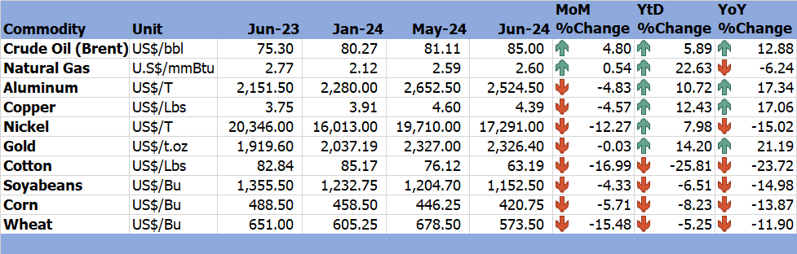

*Source: Trading Economics (2024)*

# 3.0 Zimbabwe GDP Growth Update

3.1 Economic growth in Zimbabwe is projected to reach 3.3% in 2024, 3.6% in 2025 and 3.5% in 2026 (World Bank Group, June 2024 Global Economic Prospects Report). El-Nino induced drought and low international commodity prices are dragging the country’s economic growth prospects in 2024.

Figure 2: Zimbabwe Economic Growth Prospects

*Source: World Bank Group, June 2024 Global Economic Prospects and IMF’s April 2024 WEO Report*

3.2 IMF on its April 2024 WEO report, projected a growth of 3.2% in 2024 which is 0.1% lower than World Bank Group June 2024 Global Economic Prospects projection. IMF, April 2024 WEO projections are 0.4% lesser than the World Bank Group, June 2024 Global Economic Prospects projection on Zimbabwe economic growth in 2025. The variation is attributed to improved projections on winter-crop yield and El-Nino induced drought mitigative measures which are being undertaken by the Government of Zimbabwe.

# 4.0 Merchandise Trade Developments

4.1 Zimbabwe National Statistics Agency (ZimStat) had not published the merchandise trade data on the time of compiling this report, thus the analysis remains the unchanged from the April 2024 Economic bulletin.

# 5.0 Exchange Rate Developments

## **5.1 Zimbabwean Dollar Exchange Rate Developments**

5.1.1 The ZiG depreciated against all major currencies as shown in Table 3. On a monthly basis, the ZiG lost by 2.89%, 2.14%, 1.67% and 0.74% against the USD, GBP, EUR and ZAR respectively. The ZiG also lost value against the USD, GBP, EUR and ZAR on both YtD and YoY basis.

Table 3: ZiG Exchange Rate Movements – Month Ending 28 June 2024

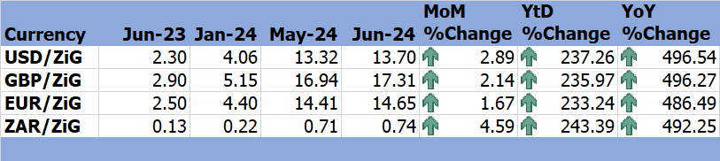

*Source: Reserve Bank of Zimbabwe (2024)*

## **5.2 Cross Rate Developments**

5.2.1 On MoM basis, the USD gained against the GBP and EUR by 0.73% and 1.21% respectively, and the USD depreciated by 1.62% against the ZAR. On a YtD and YoY basis, the USD lost gained both the GBP and EUR, albeit depreciating against the ZAR (see Table 4). The trend inhibited by the USD/ZAR exchange rate stimulates Zimbabwe exports to South Africa which boost industrialization in Zimbabwe.

Table 4: USD Exchange Rate Movements – Month Ended 28 June 2024

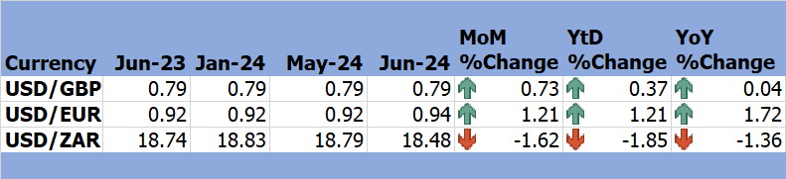

*Source: RBZ (2024)*

# 6.0 Inflation Developments

6.1 During the month under review the economy continued to record a deflation, MoM inflation stood at -0.2% up from -0.6% recorded in May 2024 (see Figure 3).

Figure 3: Month-on-Month Inflation Outturn

*Source: ZimStat (2024)*

6.2 Table 5 shows the drivers of inflation in June 2024. The main contributor to inflation is housing, water, electricity, gas and other fuels with a weight of 27.62, while food and non-alcoholic beverages being the key contributor to deflation with a weight of 31.30.

Table 5: Monthly Inflation for June 2024

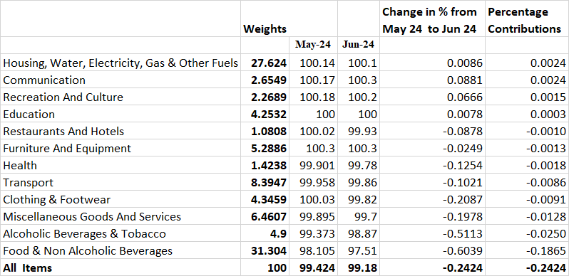

*Source: ZimStat (2024)*

# Monetary Developments

## **7.1 Money Supply and Interest Rates**

7.1.1 The RBZ had not published M3 and interest rates for June 2024 by the time compiling the bulletin hence the analysis remain the same as of April 2024 Economic Bulletin.

# 8.0 Stock Market Developments

## **8.1 Zimbabwe Stock Exchange**

8.1.2 During the period under review, the Zimbabwe Stock Exchange recoded a bullish trend. On a MoM basis, All-share index gained by 1.6%, Top 10 index gained 34.53%, Value traded grew by 3380.24% and market capitalization gained by 31.24% resulting to a market capitalisation of ZiG37506.14 million in June 2024 from ZiG28578.6 million in May 2024 as shown in Table 6.

8.1.3 On a YtD and YoY, All-share index, Top 10 index, Value traded and Market capitalisation gained except on a YtD basis where All-share index and Value traded lost by 52.15% and 8.67% respectively.

Table 6: Zimbabwe Stock Exchange Movements

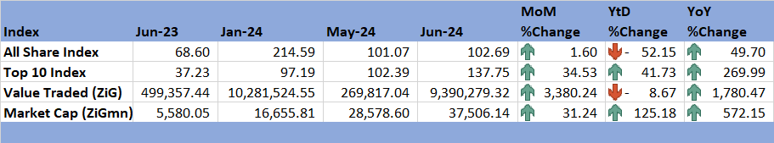

*Source: ZSE (2024)*

## **8.2 Victoria Falls Stock Exchange**

8.2.1 The Victoria Falls Stock Exchange recorded a bullish trend in June 2024. On MoM basis, the All-Share Index gained by 5.57% and market capitalization gained by 8.38% leading to the realization of USD975.87 million in June 2024 from USD900.39 million in May 2024. Meanwhile, Value traded lost by 85.64%.

8.2.3 On a YtD basis, the All-Share Index gained 0.17% while Value traded and Market cap lost 78.75% and 0.19% respectively. All-share index and Value traded gained by 25.34% and 4.51% respectively, on a YoY basis and market capitalization lost by 13%.

Table 7: Victoria Falls Stock Exchange Movements

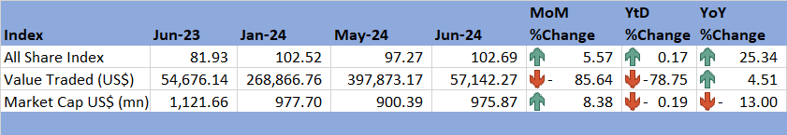

*Source: VFEX (2024)*

# 9.0 Recommendations

9.1 The following recommendations are being proposed:

9.1.1 **Economic Diversification**: The country needs to focus on industrialisation rather than basing on resource extraction and agriculture. International commodity prices especially for agricultural commodities are falling both on a MoM, YtD and YoY basis hence the economy need to industrialise and reduce dependency on agricultural commodities. The economy also needs to diversify its exports destination.

9.1.2 **Strategic Grain Reserves**: The country needs to build strategic reserves that are sufficient to sustain the economy in the event of a natural hazards such El-Nino induced drought. The government needs to resuscitate the Grain Marketing Board (GMB) through building Silos in all districts in the country as grain reservoir for the district.

9.1.3 **ZiG Stabilization**: The ZiG depreciated against all major currencies, thus, there is need for a continuous economic reforms including fiscal adjustment and rebuilding foreign exchange reserves to reinforce the value ZiG.

9.1.4 **Tracking Inflation drivers**: There is need to monitor the main contributors to inflation which are housing, water, electricity, gas and other fuels with a weight of 27.62 and food and non-alcoholic beverages with a weight of 31.30.

9.1.5 **Stock Market**: The ZSE and VFEX gained some momentum in June 2024. There is need for a continuous improvement in stock market participation through investment information dissemination to investors and potential investors.

# 10.0 References

Galt and Taggart. (2024). *Commodities Monthly Outlook.* Galt & Taggart.

IMF. (2024). *World Economic outlook Update, April 2024.* International Monetary Fund.

RBZ. (2024). *Exchange Rates*. Retrieved from Reserve Bank of Zimbabwe: https://www.rbz.co.zw/index.php/research/markets/exchange-rates

RBZ. (2024). *Resolutions of the Monetary Policy Committe Meeting Held on 26 June 2024.* Retrieved from Reserve Bank of Zimbabwe: https://www.rbz.co.zw/documents/press/2024/June/MPC_-_Monetary_Policy_Committee_Press_Statement_26_June_20241.pdf

Trading Economics. (2024). *Commodities*. Retrieved from Trading Economics: https://tradingeconomics.com/commodity/crude-oil

VFEX. (2024). *Main Dashboard*. Retrieved from Victoria Falls Stock Exchange: https://www.vfex.exchange/

World Bank Group. (2024). *June 2024, Global Economic Prospects: A World Bank Group Flagship Report.* World bank.

ZimStat. (2024). *Inflation Rates*. Retrieved from Zimbabwe Statistics Agency: https://www.zimstat.co.zw/

ZSE. (2024). *Main Dashboard*. Retrieved from Zimbabwe Stock Exchange: https://www.zse.co.zw/

**NECF Secretariat, 2024**